Different Types of Charts in Python

Matplotlib is a data visualization library in Python. The pyplot, a sublibrary of matplotlib, is a collection of functions that helps in creating a variety of charts. Line charts are used to represent the relation between two data X and Y on a different axis. Here we will see some of the examples of a line chart in Python :

Simple line plots
First import Matplotlib.pyplot library for plotting functions. Also, import the Numpy library as per requirement. Then define data values x and y.
Example 1:
# importing the required libraries
import matplotlib.pyplot as plt
import numpy as np

# define data values
x = np.array([1, 2, 3, 4]) # X-axis points
y = x*2 # Y-axis points

plt.plot(x, y) # Plot the chart
plt.show() # display

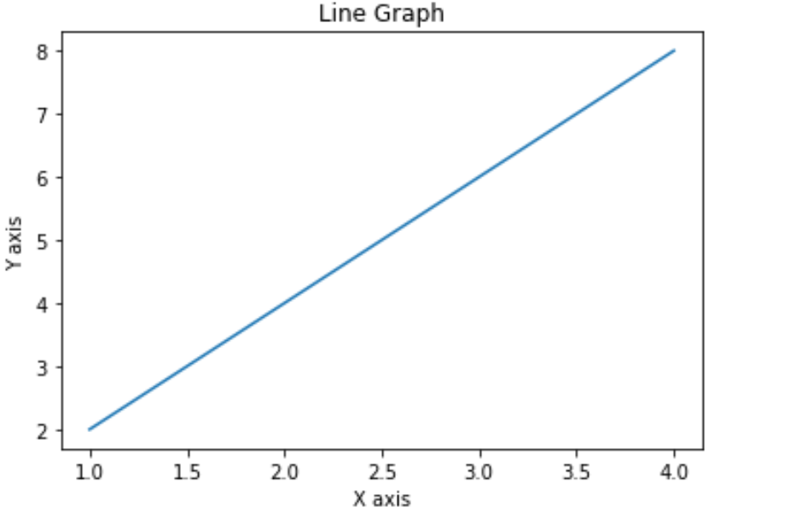

Example 2:

import numpy as np
X=np.arange(0,10,2)
Y =[i**2 for i in X]
plt.title("Square of X graph ")
plt.xlabel("x axis")
plt.ylabel("x Square axis")
plt.plot(X,Y)

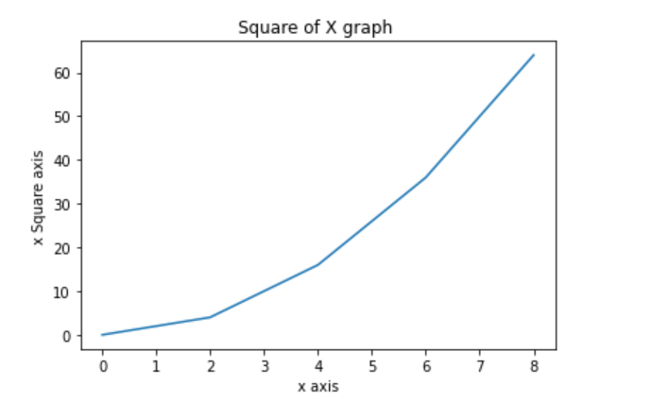

Bar Plot

A bar plot or bar chart is a graph that represents the category of data with rectangular bars with lengths and heights that is proportional to the values which they represent. The bar plots can be plotted horizontally or vertically. A bar chart describes the comparisons between the discrete categories. One of the axis of the plot represents the specific categories being compared, while the other axis represents the measured values corresponding to those categories.

import numpy as np
import matplotlib.pyplot as plt
x = ['2000','2001','2002','2003']
y = np.arange(10,50,10)
c=["red","blue","green","yellow"]
plt.title("Placement details")
plt.bar(x,y,color=c)
plt.xlabel("Year")
plt.ylabel("no of student placed")
plt.show()

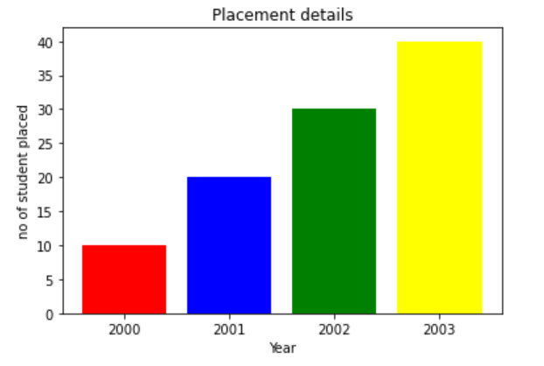

Display Multiple Plots
With the subplot() function you can draw multiple plots in one figure:
import matplotlib.pyplot as plt
import numpy as np
#plot 1:
x = np.array([0, 1, 2, 3])
y = np.array([3, 8, 1, 10])
plt.subplot(1, 2, 1)
plt.plot(x,y)
#plot 2:
x = np.array([0, 1, 2, 3])
y = np.array([10, 20, 30, 40])
plt.subplot(1, 2, 2)
plt.plot(x,y)
plt.show()

The subplot() function takes three arguments that describes the layout of the figure.
The layout is organized in rows and columns, which are represented by the first and second argument.
The third argument represents the index of the current plot.
plt.subplot(1, 2, 1)
#the figure has 1 row, 2 columns, and this plot is the first plot.

plt.subplot(1, 2, 2)
#the figure has 1 row, 2 columns, and this plot is the second plot.
So, if we want a figure with 2 rows an 1 column (meaning that the two plots will be displayed on top of each other instead of side-by-side), we can write the syntax like this:

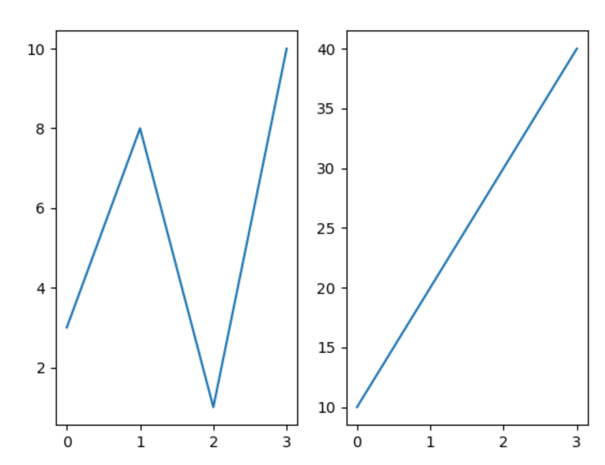

A histogram is a graph showing frequency distributions.
It is a graph showing the number of observations within each given interval.

Create Histogram
In Matplotlib, we use the hist() function to create histograms.
The hist() function will use an array of numbers to create a histogram, the array is sent into the function as an argument.
For simplicity we use NumPy to randomly generate an array with 250 values, where the values will concentrate around 170, and the standard deviation is 10.
import matplotlib.pyplot as plt
import numpy as np
marks=[10,35,45,50,55,74,25]
grade_interval=[0,35,70,100]
plt.title("Student percentage ")
plt.xlabel("percentage")
plt.ylabel("no of students")
plt.xticks([0,35,70,100])
plt.hist(marks,grade_interval)
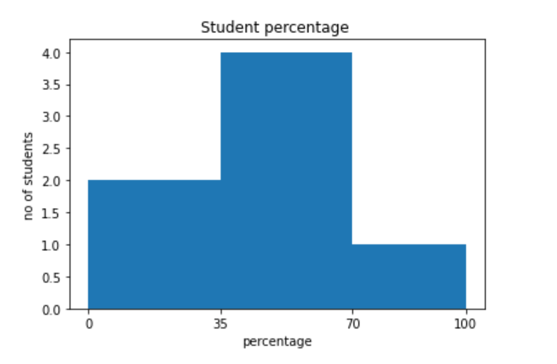

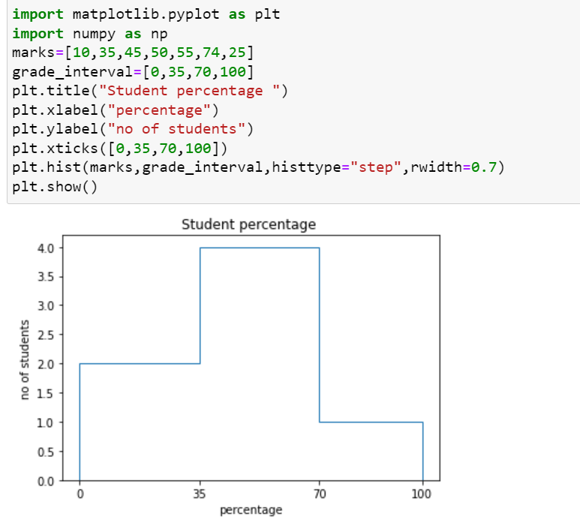

Creating Scatter Plots
With Pyplot, you can use the scatter() function to draw a scatter plot.
The scatter() function plots one dot for each observation. It needs two arrays of the same length, one for the values of the x-axis, and one for values on the y-axis:
import matplotlib.pyplot as plt
import numpy as np
x = np.array([5,7,8,7,2,17,2,9,4,11,12,9,6])
y = np.array([99,86,87,88,111,86,103,87,94,78,77,85,86])
plt.scatter(x, y)
plt.show()

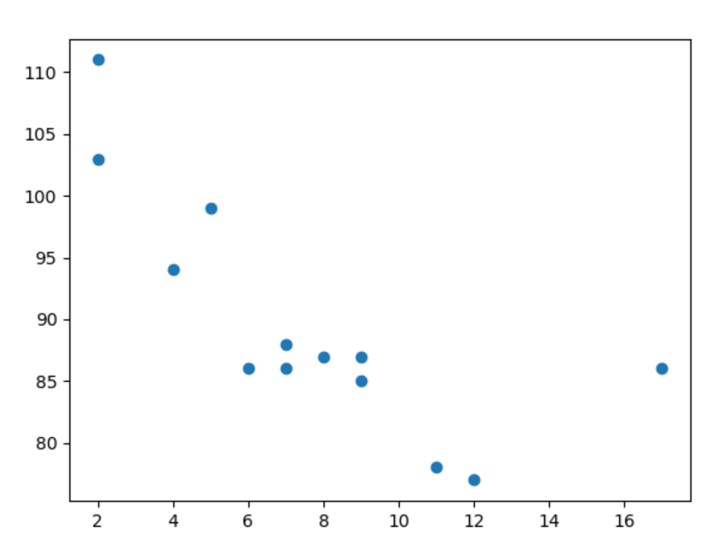

Creating Pie Charts
With Pyplot, you can use the pie() function to draw pie charts:
import matplotlib.pyplot as plt
import numpy as np
y = np.array([35, 25, 25, 15])
plt.pie(y)
plt.show()

Ex:1

from matplotlib import pyplot as plt

student_performance=["Excellent","Good","Average","Poor"]
student_values=[15,25,12,3]
plt.pie(student_values,labels=student_performance)
plt.show()

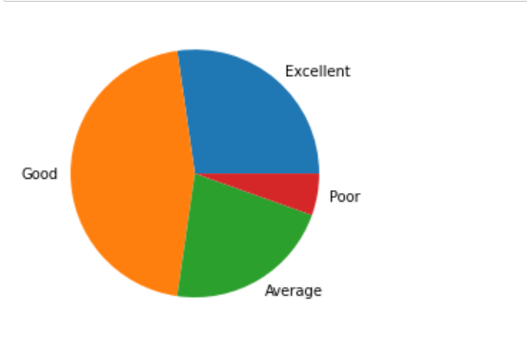

Start Angle
As mentioned the default start angle is at the x-axis, but you can change the start angle by specifying a startangle parameter.
The startangle parameter is defined with an angle in degrees, default angle is 0:
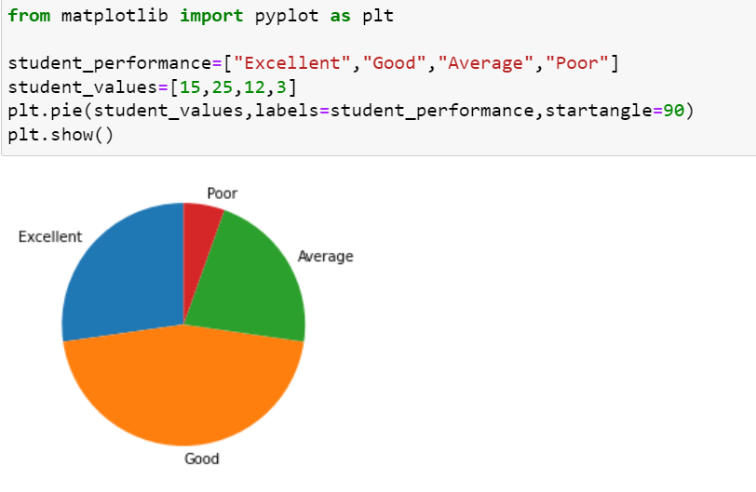

Explode
Maybe you want one of the wedges to stand out? The explode parameter allows you to do that.
The explode parameter, if specified, and not None, must be an array with one value for each wedge.
Each value represents how far from the center each wedge is displayed:
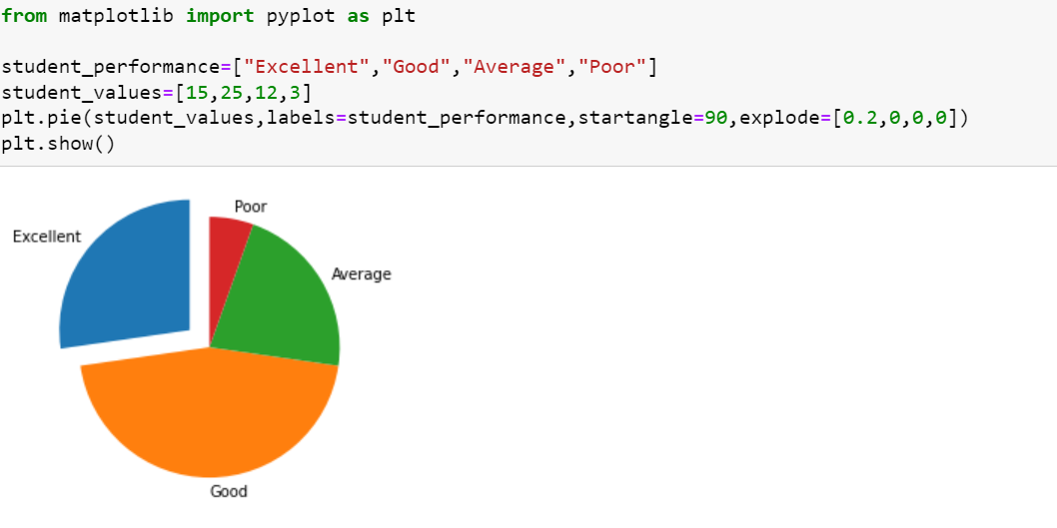

Legend
To add a list of explanation for each wedge, use the legend() function:
